19 Feb 2025
Dear Oasis Traveller,

It’s not long until we will see you in South America with some of you joining us in Rio for Carnival, and others just at the start of the trip. We hope you are excited to be starting your South America adventure! Here we have a few more updates for you including some activities you can arrange for your time in Rio before the trip starts. Please let us know as soon as possible if you would like to do any of these.

Your crew for this trip are Matt and Danny and both have bags of overlanding experience. Danny worked for Oasis for many years pre-Covid, mostly in South America which is his passion! Matt is also a seasoned overland driver and together they have been leading our 2024/25 Cartagena to Rio trip. As you may know, this will be the first time we have travelled more extensively through Paraguay and Uruguay on this route, so those sections will be new to them, but the rest of the trip they know well.

Vehicle: We do need to advise you of a potential change to our planned vehicle for the trip. We have had some issues with our scheduled truck, which has a strange recurring issue that is proving frustrating to pin down and fix. The vehicle is being worked on in a mechanics workshop near Buenos Aires at the moment. There is a possibility that if it is not fixed in time to get to Rio for the start of your trip, then we will start off using a backup overland truck instead. We are ready for that scenario if necessary, but wanted to let you know that you may not start the trip on one of our normal yellow Oasis trucks. If that does happen, then the plan would be to switch over to our scheduled Oasis truck part way through the trip. The crew will update you in Rio about this when you meet them there.

Trip Joining Point – Rio de Janeiro
Hotel Riazor
Address: Rua do Catete, 160 - Catete, Rio de Janeiro
Telephone: +55 21 2225-0121
Start Time Day 1 (4th March): 08:00 (to be reconfirmed at the pre-trip meeting)

Rio Pre-departure Meeting
There will be a trip pre-departure meeting in the starting hotel the night before the start of the trip. There will be a notice in reception advising the exact time (normally 6pm) and here Danny will explain how the day to day running of the trip works. He will collect your Local Payment money as well as 2 photocopies of your passport information page. It is important that you attend this meeting so please let us know if you are unable to do so.

If you need to contact Danny once you are in Brazil/Argentina or if your flights are delayed and you think you won’t be there on time, you can WhatsApp him on +44 7746 155690. Please remember to tell him who you are! Please also hold off contacting him until a couple of days before your start date at least, as he will be busy running the current trip and not readily available.
Our UK 24 hour emergency number if you can’t reach Danny is +44 203 633 3041.

Local Payment
Remember to have your local payment ready to pass onto Danny at the start of the trip. You may find it easiest and cheapest to book this online to pick up at your departure airport. This should give you a good rate and save you carrying a lot of cash for a long time before the trip starts. If possible, please bring mainly larger $50/$100 notes for your LP.

Optional Activities in Rio
Our trip that is currently travelling en-route to Rio arrives there in time for Carnival and our local partner Luiz from Be a Local Tours is arranging some activities and excursions for the group. If you will be in Rio and would like to take part in any of the following, please let us know as soon as possible and we will do our best to get you on the activity that will be with our group, subject to availability:

Friday 28th February – City Tour
Explore the city’s most iconic sights, including Christ the Redeemer, Santa Teresa, the Metropolitan Cathedral, the Selarón Steps and Sugarloaf Mountain. Full day activity – transport is a minibus.
Cost: 486 Brazilian Reals

Saturday 1st March – Hang Gliding
Amazing adventure tandem flight across Rio, taking off from the mountain in the Tijuca National Park and landing on the beach. Stunning scenery and one of the most popular activities in Rio. Half day activity in the morning.
Cost: 1296 Brazilian Reals

Saturday 1st March – Favela Tour
Experience the vibrant culture of Rio’s favelas and learn about the incredible social projects that help their communities. Half day activity in the morning or afternoon.
Cost: 162 Brazilian Reals

All activities must be paid for in advance and include an 8% fee for paying by Paypal directly to Be a Local Tours (we will send payment details). No shows are non-refundable.

Sambadrome parade – Saturday 1st March – applies to those who have purchased Sambadrome tickets through us
Please meet Danny and the group at 8pm in the Hotel Riazor reception on Saturday 1st. Remember to have your ticket on the app on your phone and be dressed to party! The brighter, wilder and more glittery, the better!

If you haven’t yet, don’t forget to download your Sambadrome ticket – first download the Quentro app (see below) and register using your email address. Once you have done this, tell us the name and email address you have used so that our local partner Luiz can apply your ticket to your account. Please take care to send us the correct details and please do this as soon as possible to ensure you receive your tickets in time!

If you are travelling with one or more people, then all your tickets can be sent to one registered email address, but be aware that you must enter the Sambadrome together.

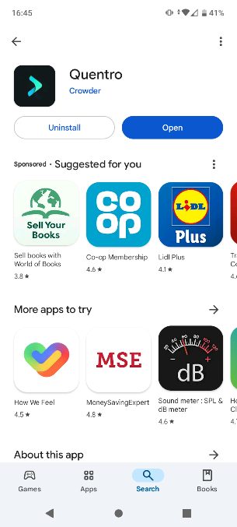

Apple – AppStore - https://apps.apple.com/us/app/quentro
Android – PlayStore - https://play.google.com/store/apps/details?id=com.getcrowder.quentro

As a reminder, we have purchased tickets in Sector 5 for the evening of Saturday 1st March and we have been issuing refunds for the difference in the cost of these tickets to the price you paid for Sunday tickets for Sector 12/13.

Chile visa for Australian passport holders - only applies to those travelling through Chile
Please see our previous updates for information about how to apply for your visa and do let us know how you are getting on with the application.

Luggage
This is just a reminder that luggage space is limited on the truck. You should make sure to try and pack light and only bring a soft sided main rucksack or holdall which will be stored in the locker under your seat, plus a small day pack to keep inside. Suitcases will not fit, and bags with rigid sides are not suitable either.
If you bring too much luggage with you, you will be asked to post it home before you join the trip.

We hope you have an incredible time in South America! Please do share your photos on Facebook and Instagram, we love to see them!

