Dear Traveller,

Your trip to South America will soon be upon us and we have some important updates and information here for you.

* Traveller information and passport copy
* Chile visa
* Sambadrome tickets
* W-trek Add on

*Note: This update is being sent to everyone booked on various legs of the trip starting in Rio and Buenos Aires so not all the information may apply to everyone.*

*We will be sending a final update in a couple of weeks time with details of your crew, joining instructions, arrangements for your local payment, pre-departure meeting information and contact numbers etc.*

**Traveller information and passport copy**

If you have not already completed and returned your Travellers Information Sheet and Passport Copy to us, please do this now as we need the information to book various parts of your trip. [You can download the form here…](https://www.encounterstravel.com/downloads/OASIS_TRAVELLERS_INFO_SHEET.rtf)

We are still missing some people’s travel insurance details, emergency contact details and other information and we need all this before the trip starts.

Lastly, can you also please let us know if you are travelling as a couple to help with some of our accommodation bookings.

**Chile visa for Australian passport holders** - o*nly applies to those travelling through Chile*

Australian passport holders need to obtain a visa in advance by applying through the Chilean e-visa website. This website states that the process takes 10 working days however the Australian government website (<https://www.smartraveller.gov.au/destinations/americas/chile>) states that it can be a much lengthier process so you should apply right away.

The process is not always straightforward, so please see our accompanying detailed instruction file explaining the documentation required and the process to follow.

**Sambadrome tickets –** *applies to those starting in Rio who have purchased Sambadrome tickets through us*

Paper tickets for the Sambadrome event have now been discontinued and instead tickets will be issued to an online app on your phone. Please download the Quentro app (see below) and register using your email address. Once you have done this, tell us the name and email address you have used so that our local partner Luiz can apply your ticket to your account. Please take care to send us the correct details. If you are travelling with one or more people, then all your tickets can be sent to one registered email address, but be aware that you must enter the Sambadrome together.

Please do this as soon as possible to ensure you receive your tickets in time.

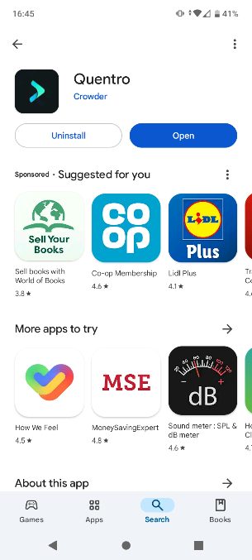

Apple – AppStore - <https://apps.apple.com/us/app/quentro>

Android – PlayStore - <https://play.google.com/store/apps/details?id=com.getcrowder.quentro>

As a reminder, we have purchased tickets in Sector 5 for the evening of Saturday 2nd March and we are in the process of issuing refunds for the difference in the cost of these tickets to the price you paid for Sunday tickets for Sector 12/13.

Saturday is part of the Access group of Samba schools. The competition is fierce in this category, as the winner will get through to the Special group parade the following year. So, you have ambitious smaller schools wanting to move up, and large schools that dropped down last year desperate to return again.

There will be around 35 of you going together, with people joining from several different trips.

We hope you have a wonderful time there and look forward to seeing some pictures of you in your costumes!

**CHILE – W Trek Add On**

For those travelling beyond Buenos Aires, we have a few places available on the W Trek. If you would like to do this and haven’t let us know already, please get in touch.

While we are in Chile, we spend several days in Puerto Natales, right next to Torres del Paine National Park. While you are there, there is an option available to do the W Trek priced at £1150 per person. This covers a 4 day/3 night W Trek arranged by our local partners there, as well as a night at their accommodation in Puerto Natales before and after the trek.

Places are on a first come first served basis. The W Trek is one of the world’s most famous treks, and is a challenging walk with some tricky terrain and steep ascents and descents. You do not need to be a specialist or experienced hiker to complete the trek, but you do need to be in moderate to good health with a decent level of fitness. You will be carrying your own backpack with sleeping bag and mat (both provided, though you will have your own for the trip anyway) and clothes for the trek. The four hiking days are approx. 18km (7-8hrs), 14.5km (6.5hrs), 20.3km (9hrs) and 11km (3.5hrs).

For more detailed information about the W Trek arrangements, inclusions/exclusions etc., go to the trip page on our website, click on the ‘Essential Information’ tab, and then the ‘Additional Information’ section.

If you do not want to do the trek, then you can remain in Puerto Natales and take day trips into Torres del Paine National Park. We include an entry ticket for you to the park in our trip price. This would include being able to do the famous Base of the Towers trek together with the W Trek group on their first day (but returning back to Puerto Natales afterwards). You can also take boat trips to se the glaciers up close, or to nearby islands to see penguins. All these day trips can be arranged while you are in Puerto Natales – there is nothing you need to do now.

*If you would like book, please contact us to check availability. The full payment of £1150 is due at the time of booking.*