Oct 2024

Dear Oasis Overland traveller,

We hope you are looking forward to your South America adventure with us! We are delighted that you will be joining the trip.

*Note – this update is written to cover the whole of the trip between Rio and Cartagena. As we get some people booking the whole thing, and others just doing shorter sections, not everything in this document may apply to you. We have tried to make it as clear as possible, so just skip past anything that relates to a country that you will not be visiting. Thank you.*

The truck is scheduled to start in Rio on the 4th March after Rio Carnival celebrations, continuing to Buenos Aires, Ushuaia, Santiago, La Paz, Lima, Quito and Cartagena. So far we have enough numbers to guarantee the trip as far as Santiago, but still need more people beyond that. It is early days for the second half of the trip though. If you would like to extend your trip or have anyone who would like to join you, please let us know.

Back here at Oasis HQ we have been working hard putting as much advance preparation in place as possible. We will continue updating the Essential Information section of each trip page on our website as new information comes in, so please do keep an eye on this.

In the meantime, we have a few important updates for you regarding paperwork, optional add-ons and personal spending money.

But first…

**What to expect!**

On all our trips you should expect the unexpected, with the itinerary and route having to adapt at times, even whilst en route. This could be due to the distances covered, border closures and visa changes to name a few!

This is about as far away from your average holiday as you can get, as at times we travel to places where roads are poor, the heat is extreme or the cold is bitter, and some people may be on the road for 2-3 months or more.

You may have to help carry heavy sand mats if the truck gets bogged and you will all get involved in the cooking and the cleaning, as well as setting up and taking down the tents. There will also be the occasional bush camp on this trip, which means no campsite facilities, but rather dig a hole and a ‘shower in a can’ moments will happen! Much of the time we will stay in hostels or basic hotels and standards can vary considerably. Often, we are restricted by what is available to us so you could find yourself bush camping in a remote area, setting up camp at a roadside fuel station, sleeping under canvas in a national park, sharing a dorm room in a busy city or, what will become quite a luxury, a twin/double en suite room. The percentage mix of camping to hostel/hotel accommodation depends on the section of the trip you are joining – have a look at your trip on our website.

Together with these challenges you should also expect numerous amazing moments, meeting local people, exploring stunning scenery and seeing some of the world’s most iconic sites. All in all this is going to be a really special trip that you’ll remember forever. Most important is that you approach it with a positive and flexible attitude, and are prepared to get stuck in and help out as part of team. The more everyone does that, the better all these trips run.

**ADD-ONS**

There are several add-ons available for you to choose from during this trip. Several of these require advance booking and payment for us to secure permits and available space. Ssme of these are listed below. There are some imminent deadlines for booking some of these, so please check carefully.

**BRAZIL – Rio accommodation - £275 / £495**

If your trip starts in Rio, then you may like to add a pre-trip accommodation package there with us so that you can stay together with the rest of the group and enjoy the city and the Rio Carnival parades and events.   
If you would like to add this to your booking and have not done so already, please let us know so that we can manage our hotel allocation.

Prices for 5 nights staying in the budget Hotel Riazor from the 27th February to the 4th March are GBP 275 p/p in twin, triple or double, or GBP 495 p/p in a single room. This includes breakfast.

***What to do now…***  
*- Tell us by the 31st October if you want to add this accommodation package. - We will then invoice you for the accommodation.*

We have plenty of rooms reserved, but space is subject to availability and the number of bookings required.

We will need to start releasing unallocated rooms soon, and availability after that will be on a request basis.

**BRAZIL – Sambadrome ticket - £45**

Join us in Rio de Janeiro for an incredible evening's entertainment at the famous Sambadrome, home of the main Carnival parade. We will be booking tickets for anyone travelling on our tours starting or finishing, or passing through Rio during Carnival who would like to go, so that everyone can travel there and back and sit together. This will include your group, and the group we have that will have just arrived in Rio having done your trip in the opposite direction.

We will be visiting on Sunday evening (2nd March), which is one of the Special Group parades, featuring 6 of the very best Samba schools in Rio. We will be booking tickets in **Sector 13**, which is a large uncovered grandstand at the end of the parade. This means you get to see the whole the parade coming towards you. Access in and out of this area has proved OK in the past, and it is fun to be mixing in that stand with the locals and not to just be surrounded by large cruise boat groups or other tourists. It is also much better value than some of the other stands which can cost $100-$200+ per ticket.

***What to do now…***  
*- Tell us* ***now*** *if you would like to add this ticket. We will add it to your booking and send you a link for payment.*

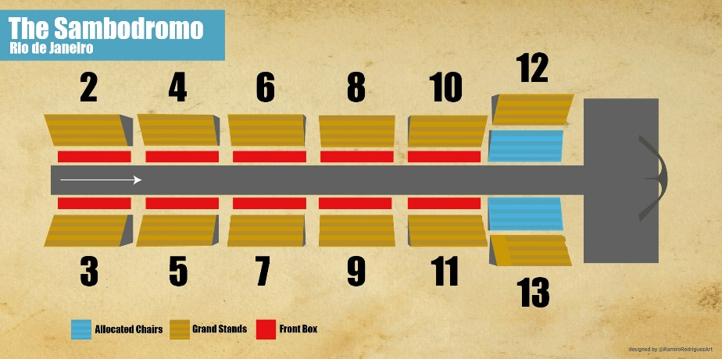

**CHILE – W Trek - £1150**

While we are in Argentina, we spend several days in Puerto Natales, right next to Torres del Paine National Park.

While you are there, there is an option available to do the W Trek priced at £1150 per person for 2025 departures. This covers a 4 day/3 night W-Trek arranged by our local partners there, as well as a night at their accommodation in Puerto Natales before and after the trek. We have places reserved to do the trek with them. However, these places are on a first come first served basis.

The W Trek is one of the world’s most famous treks, and is a challenging walk with some tricky terrain and steep ascents and descents. You do not need to be a specialist or experienced hiker to complete the trek, but you do need to be in moderate to good health with a decent level of fitness. You will be carrying your own backpack with sleeping bag and mat (both provided, though you will have your own for the trip anyway) and clothes for the trek. The four hiking days are approx. 18km (7-8hrs), 14.5km (6.5hrs), 20.3km (9hrs) and 11km (3.5hrs).

For more detailed information about the W Trek arrangements, inclusions/exclusions etc., go to the trip page on our website, click on the ‘Essential Information’ tab, and then the ‘Additional Information’ section.

If you do not want to do the trek, then you can remain in Puerto Natales and take day trips into Torres del Paine National Park from there. We include an entry ticket for you in our trip price. This would include being able to do the famous Base of the Towers trek together with the W Trek group on their first day (but returning back to Puerto Natales afterwards). All these day trips can be arranged while you are in Puerto Natales – there is nothing you need to do now.

***What to do now…***  
*- Tell us by the 31st October if you want to do the W Trek (if you haven’t already).*

*- So that we can confirm camping spots, permits and accommodation for you, there will be a non-refundable £500 deposit payable now. The remainder of the £1150 will be payable with your main trip balance payment.*

**OPTIONAL EXCURSIONS AND PERSONAL SPENDING MONEY**

There are many optional excursions you can arrange during your trip and we are continuing to update the Optional Excursion costs shown on our website. However, we know that some costs may have increased since our last trip, and there may be activities that are no longer available or have changed.

In addition, please bear in mind recent global price increases and fluctuations in currency exchange rates. As such we would suggest budgeting at the higher end of our spending money suggestions, found in the Essential Information for each trip. Personal spending money can vary so much between travellers but we hope this helps you to plan. We always recommend having a contingency fund and it’s always worth having a bit extra as a buffer for those ‘must buy’ purchases you may find en route!

Please remember that our personal spending money suggestions do not include paying for Optional Excursions or visas, nor your Local Payment, therefore these should be accounted for separately.

**PAPERWORK**

So that we can book accommodation and prepare passenger manifests for border crossings etc., we need a certain amount of information in advance from everyone. This includes all your personal details, home address, emergency contacts, travel insurance details, your profession etc.

You can provide these to us by filling in the Traveller Information Form which was sent to you when you booked. We are still waiting to receive quite a few of these, so would ask kindly that if you have not sent yours in yet, please do so as soon as possible. You can leave off your travel insurance details if you don’t have it arranged yet (though bear in mind that cancellation cover will only kick in after your policy has been purchased).

[You can download the form here…](https://www.encounterstravel.com/downloads/OASIS_TRAVELLERS_INFO_SHEET.rtf)

We also need a copy of everyone’s passport identity page. If you have not sent this to us yet, please do so as soon as possible. This can be a scan, or a photograph taken with your phone (please make sure there are no reflections, fingers covering parts of the passport, and everything is clearly legible).

Best wishes, the Oasis Overland team